CITY OF LONDON · ONTARIO
THE PUBLIC-RECORDS
LEDGER
Final Public Edition 5.0
A source-locked municipal accountability review
with finished dispositions for all twelve research asks

12 / 12  research asks dispositioned  No placeholder modules remain | 8  built from public records  Evidence-complete at published depth | 4  records-dependent  Filing-ready requests supplied

Prepared by Raj Gandhi
Evidence lock: August 20, 2026
Independent review — not an official audit or assurance engagement
EDITION NOTE

What the Final Public Edition delivers
Edition 4.0 closed the analytical workflow. Final Public Edition 5.0 packages that source-locked work for public release: every original ask now ends in either a reproducible public-record finding or an exact request for the transaction-level records needed to finish testing.
The governing conclusion
The record supports a material disclosure-and-performance-measurement problem. It does not, by itself, establish fraud, corruption, favouritism, or waste. The strongest next move is targeted disclosure and traceable reconciliation—not allegation.

Material additions
- A two-page briefing prepared for Councillor Susan Stevenson, with questions and motion-ready disclosure asks.
- Current 2026 budget figures, a 2025 audited-financial update, and a reproducible three-scenario DC-reserve sensitivity test.
- A policy-versioned procurement compliance screen using the October 1, 2025 policy transition and the 2025 compliance reports.
- A 42-recipient, $9.2 million 2024–2027 community-grants ledger plus the City’s first outcome report and MNP’s two open control findings.
- A real housing-delivery ladder that separates permits, tracked affordable units, in-progress units, planned units, and occupied highly supportive housing.
- Built service modules for transit and police, and a disclosure-availability matrix with exact requests for fire, roads, water/wastewater, recreation, fleet, IT, real estate, legal/insurance, and incentives.
- A true crosswalk of published internal-audit reports, recommendations, management responses, deadlines, and follow-up status.
- A companion machine-readable evidence workbook containing the claim register, source register, calculations, project dossiers, audit crosswalk, reform sequence and records-request specifications.

Corrections carried into this edition
- The 2023 maintain-current infrastructure gap rose 66.3% from the 2019 plan; it did not nearly double. It approximately doubled from the 2014 plan.
- HHI is presented only as a descriptive concentration statistic for the disclosed-value slice. It is not market concentration, and obsolete enforcement thresholds are not used.
- A favourable PSAB variance is described neutrally as actual exceeding the budgeted annual surplus—not as a service-performance win.
- Historical awards are tested against the policy version in force at the time, not retroactively against the October 2025 policy.
- The former claim that the internal-audit crosswalk was already built is withdrawn; the crosswalk is actually built in Part 9 of this edition.
TWO-PAGE BRIEFING · PAGE 1 OF 2

Briefing for Councillor Susan Stevenson
Purpose: provide a short, evidence-safe set of questions for Audit Committee or Council. This note does not ask the recipient to endorse the report’s analysis; it asks for records and reconciliations that would let Council and the public test the City’s own published claims.
70.5%  posted award records without visible value  1,394 of 1,978 scraped records | $946.1M  10-year renewal gap  +66.3% from 2019 | $182.6M  2025 PSAB surplus over budget  Audited statement; not cash surplus

What is now firmly in the record
- The City publishes large capital, reserve, grant, housing and service numbers, but the records often stop before an end-to-end budget → award → amendment → payment → output reconciliation.
- The 2025 DC reserve report shows contributions of $68.5 million, disbursements of $106.2 million and a closing balance of $327.1 million across the eleven funds; that is a $37.7 million net draw in one year.
- London’s 2025 development report tracks 2,576 City-funded affordable units, but only 44 City-led highly supportive housing units are explicitly described as completed and occupied. The stages are not interchangeable.
- The 2024–2027 community-grants cycle names 42 recipients and $9.2 million. MNP found no documented score-to-award threshold and no mandatory panel scoring rationale in SmartSimple; both actions remain on track for Q4 2027.
- The City’s outsourced internal auditor has now reported on grants, homelessness, performance measurement, CIPs, the CEAP and subdivision review. Follow-up reporting exists, but the public-facing program/project ledgers still do not consistently join money to outputs.
Best single question
Will administration publish, for every major capital project and incentive program, one machine-readable row connecting original authority, current budget, award, amendments, committed amount, paid amount, schedule, output and closeout status?

SOURCE LOCK S02, S10, S12, S14–S24 · All figures and audit-status statements are traceable in the source register.
TWO-PAGE BRIEFING · PAGE 2 OF 2

Questions and motion-ready disclosure asks

Six questions
- Capital: For each project over $10 million, what are the original approved budget and schedule, current forecast-at-completion, approved amendments, committed amount, paid amount and physical completion percentage?
- Procurement: Can the 2025 Annual Procurement Compliance Review and biannual award reports be published as a row-level machine-readable dataset, including limited-tendering authority, amendment value and Council approval reference?
- Workforce: Will the City publish annual FTE, vacancy, overtime, turnover, span-of-control and contractor-equivalent data by service and management layer?
- Housing: Can the City publish stable project identifiers that connect application, approval, permit, start, completion, occupancy, affordability term, municipal contribution and ongoing monitoring?
- Grants and CIPs: Will the City publish the application score, rationale, amount requested/approved/paid, agreement milestones, outcome measures, closeout and clawback status for every recipient?
- Internal audit: Can the follow-up dashboard include the full management action, accountable owner, original due date, revised due date, evidence of closure and public link to the underlying deliverable?

Draft direction for consideration
Proposed wording
That Civic Administration report back with a public, machine-readable municipal accountability ledger linking major capital projects, procurement awards and amendments, grants/CIP incentives, and housing investments to authority, financing, payment, schedule, output and closeout status; and that the report identify fields that cannot be published and the legal basis for each exclusion.

If Council prefers a narrower first step, the same direction can be piloted on: Highbury Facility rebuild; Mud Creek Phase 2B; Wharncliffe/Horton; the 2024–2027 Community Grants cycle; Hubs; and Office-to-Residential incentives.

What not to say
- Do not call a budget, allocation or maximum a payment.
- Do not treat an application, permit, start, completion and occupancy as the same housing stage.
- Do not infer sole-sourcing or favouritism from vendor share or an absent posted dollar value.
- Do not use the Sunshine List as total workforce headcount.
NAVIGATION

Contents
Use Word’s Navigation pane to jump among the heading levels. The map below is deliberately static so it remains visible in PDF and preview renders; Word can also build a page-numbered table from the embedded heading structure.
Section | Subject | Section | Subject
Part 1 | Executive verdict and closure ledger | Part 7 | Housing delivery and homelessness
Part 2 | Verification standard, scope and method | Part 8 | Community grants and CIP incentives
Part 3 | Financial baseline and condition | Part 9 | Service-specific performance modules
Part 4 | Capital condition and project dossiers | Part 10 | Strategy-to-output and internal audit
Part 5 | Procurement compliance screen | Part 11 | Reforms and implementation sequence
Part 6 | Workforce and productivity | Appendix A | Six filing-ready records requests
Appendix B | Claim Verification Register | Appendix C | Official source register
Appendix D | Calculations and caveats | Appendix E | Public-use and verification declaration

Evidence status key
BUILT means the public record supports a completed, reproducible analysis at the stated scope. RECORDS-DEPENDENT means the analytical test is fully specified but the City-held transaction-level input is not public. Neither label is a finding of wrongdoing.

PART 1

Executive verdict and closure ledger
Final Public Edition 5.0 is strong enough for evidence-led outreach. Its central finding is narrower—and more defensible—than a conventional “municipal audit” headline: London publishes many authoritative numbers, but its public reporting architecture often prevents an outsider from following a dollar from authority through procurement and delivery to the promised outcome.
Overall strength
Strong as a source-locked accountability brief; moderate as a transaction audit. The report can establish disclosure gaps, reconcile published totals, reproduce arithmetic, and identify control findings already made by MNP. It cannot certify the books or test non-public invoices, bid evaluations, amendments, payroll, HR or project-control records.

Twelve original asks: final disposition
# | Original ask | Edition 3.0 | Final disposition
1 | Named case files | Partial | BUILT — eight public-record dossiers; missing change-order/closeout data routed to Request R1.
2 | Procurement compliance | Partial | BUILT — policy-versioned compliance screen; row-level bid/amendment test routed to Request R2.
3 | Operating budget | Partial | BUILT — 2024 audited functions, 2025 audit update and 2026 service budgets; sub-service ledger in R3.
4 | Workforce productivity | Not built | RECORDS-DEPENDENT — public salary screen completed; official complement, layers, vacancy, overtime and turnover in R3.
5 | Financial condition | Mostly built | BUILT — corrected interpretation, 2025 audit update and reproducible DC sensitivity scenarios.
6 | Per-project capital | Not built | RECORDS-DEPENDENT — public dossiers completed; baseline/FAC/schedule/change-order package in R1.
7 | Strategy → output | Lead only | BUILT — CEAP, performance-measurement and public-dashboard traceability crosswalk.
8 | Grants and CIPs | Substantial | BUILT — all 42 multi-year recipients, all 16 2025 annual recipients, outcome report and audit findings.
9 | Housing conversion funnel | Partial | BUILT — stage-separated 2025 ladder; address-level cohort ledger in R4.
10 | Service modules | Leads only | RECORDS-DEPENDENT — transit/police built; availability matrix and KPI extracts for remaining services in R5.
11 | Internal-audit crosswalk | Overstated | BUILT — reports, observations, responses, due dates and follow-up status now crosswalked.
12 | Evidence/publication system | Partial | BUILT — briefing, claim register, sources, calculations, records package and public-use rules.

The six highest-value findings
- Procurement disclosure remains structurally weak: 1,394 of 1,978 scraped award records carried no visible dollar value. This is a posted-record finding, not a measure of total City procurement.
- The maintain-current infrastructure gap reached $946.1 million in the 2023 plan—66.3% above the 2019 cycle and 103.0% above 2014.
- Across eleven DC reserve funds, 2025 contributions were $37.7 million below disbursements and the closing balance fell to $327.1 million; a simple repeat-draw scenario demonstrates why project timing and commitments matter.
- The 2025 audited PSAB annual surplus was $463.734 million versus a $281.085 million budget, a $182.649 million variance. That is not the same as the City’s tax-supported operating surplus or free cash.
- The grants ledger is now complete for the current multi-year cycle: 42 recipients, exactly $9.2 million over four years. The City’s impact report says recipients served an average 164,003 Londoners per year and leveraged more than $50 million, while MNP identified two unresolved allocation-control weaknesses.
- Housing reporting is improving but still mixes scopes in public debate: 5,462 residential units received permits in 2025; 2,576 City-funded affordable units were tracked; 675 were in progress and 1,360 in planning; 44 City-led highly supportive units were completed and occupied.
SOURCE LOCK S01–S24
PART 2

Verification standard, scope and method

Five tests
Test | Rule | Application
1 | Primary source | Official City, board/commission, provincial disclosure or an attachment placed on a City agenda.
2 | Scope | Period, entity, unit, support type and population are explicit.
3 | Status | Approval ≠ budget ≠ award ≠ commitment ≠ payment ≠ completion ≠ outcome.
4 | Reproduction | Displayed arithmetic can be recalculated from cited figures.
5 | Language | Interpretation does not outrun the source; material limitations sit beside the claim.

Evidence labels
Label | Meaning | Permitted use
VERIFIED | Directly stated in a source and scope-matched. | May be stated as a sourced fact.
DERIVED | Arithmetic from verified source figures. | May be used if calculation is shown.
LIMITED | Verified at a narrower scope than the headline question. | Use only with the limitation adjacent.
REQUESTED | Required input is City-held and not located publicly. | No substantive conclusion until received.
CORRECTED | Prior wording overstated or misframed the evidence. | The current source-locked wording supersedes it.

What this is—and is not
This is a public-records ledger and analytical review. It is not a financial-statement audit, forensic audit, legal opinion, engineering review, procurement protest, value-for-money assurance opinion or certification of City records. KPMG’s audited financial statements and MNP’s internal-audit reports are treated as sources; this document does not reproduce their assurance work.

Current-record rule
Records were checked through August 20, 2026. The current procurement policy took effect October 1, 2025; earlier awards are evaluated under the legacy policy. The 2025 audited statements, June 2026 internal-audit reports, 2025 LTC report, 2025 LPS report and 2026 budget update supersede older availability statements where applicable.
No false completion
A module can be finished even when a conclusion is not available: the test, denominator, source gap, responsible record-holder and requested fields are specified. That is a completed evidence disposition—not a placeholder and not permission to guess.

PART 3

Financial baseline and condition

3.1 2026 approved budget frame
$1.468B  property-tax operating expense  $926.085M levy | 3.4%  2026 rate increase  Down from prior 6.4% | $5.764B  10-year capital plans  Three support types

The 2026 Annual Budget Update reports $1.467820 billion in property-tax-supported operating expenditures, $541.735 million in non-tax revenue and a $926.085 million tax levy. The corresponding 2024–2033 capital plans total $3.588 billion property-tax supported, $707 million water supported and $1.469 billion wastewater-and-treatment supported. These support types must not be collapsed into an unlabeled total.
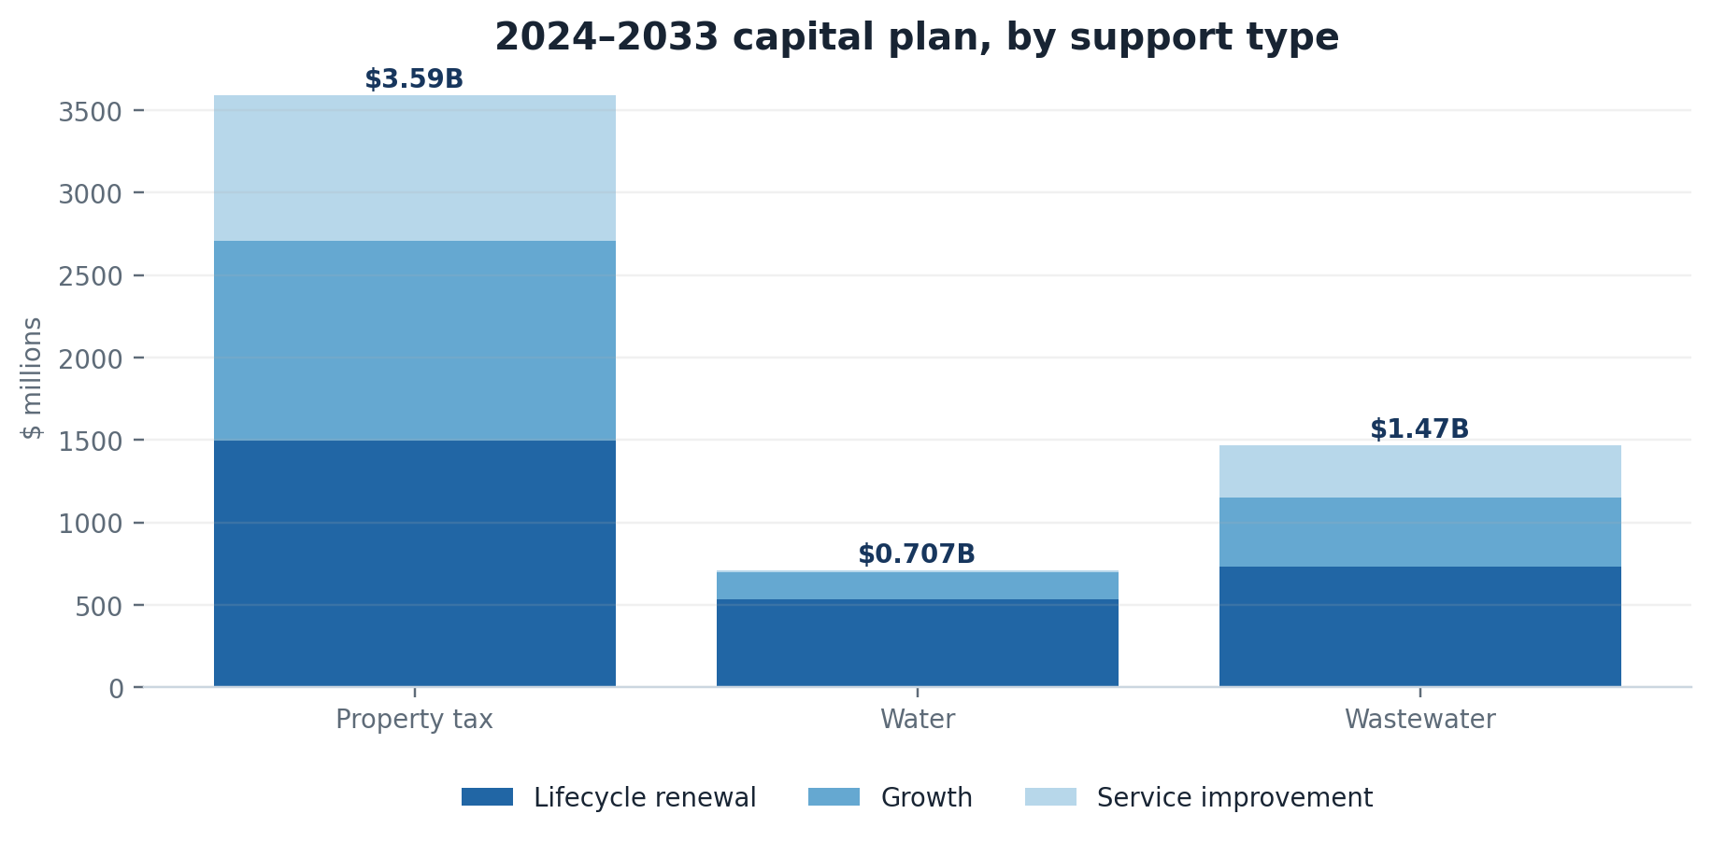
Figure 1. Approved capital authority, not payment or final cost. Source: S01.
SOURCE LOCK S01

3.2 2024 audited operating expenses
The 2024 Consolidated Statement of Operations is the most recent functional budget-versus-actual table reproduced at service-function level in this ledger. Actual expenses were below budget in eight of nine PSAB functions; transportation was 3.6% above budget. The largest percentage gaps were social housing (−28.2%) and planning and development (−24.4%). Those are screening results, not explanations.
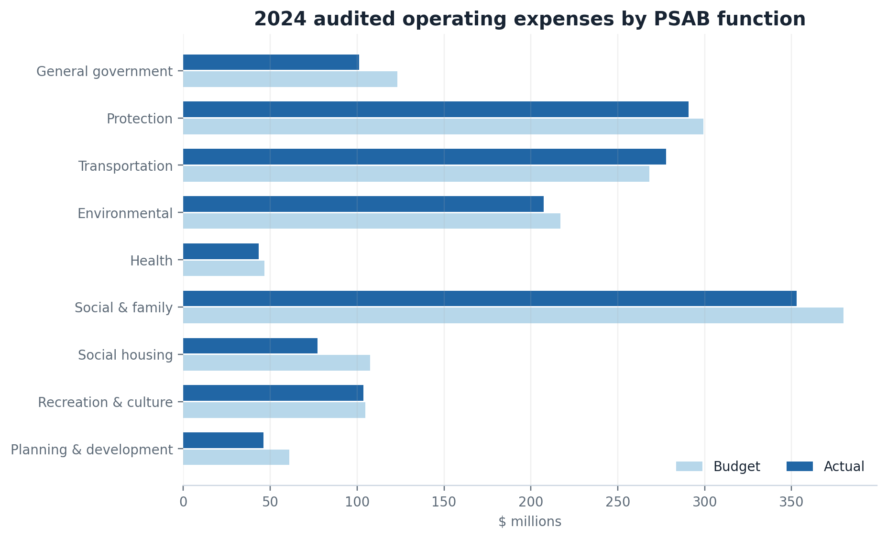
Figure 2. Broad PSAB functions; they are not individual services or facilities. Source: S11.
PSAB function | Budget | Actual | Variance
General government | $123.1M | $101.1M | −17.9%
Protection | $299.3M | $290.8M | −2.8%
Transportation | $268.1M | $277.7M | +3.6%
Environmental | $217.1M | $207.4M | −4.4%
Health | $46.6M | $43.5M | −6.6%
Social & family | $380.0M | $353.0M | −7.1%
Social housing | $107.6M | $77.3M | −28.2%
Recreation & culture | $104.8M | $103.5M | −1.3%
Planning & development | $61.1M | $46.2M | −24.4%

SOURCE LOCK S11

3.3 2025 audited update
Audited annual surplus
Budget $281.085M · Actual $463.734M · Variance +$182.649M (+65.0%). This PSAB figure includes accrual accounting, capital contributions and non-cash items; it is not the tax-supported operating surplus and is not unrestricted cash.

The 2025 statements were released in July 2026. They update the annual-surplus line and preserve the 2024 comparator of $418.052 million. The neutral accountability question is why actual and budget diverged—not whether the City “beat” a performance target. The City’s 2025 consolidated financial presentation attributes the variance in part to higher-than-expected investment income and transfer payments.
SOURCE LOCK S12, S13

3.4 Development-charge reserve pressure
$68.5M  2025 contributions  Revenue plus interest | $106.2M  2025 disbursements  Across 11 funds | $327.1M  2025 closing balance  Down $37.7M net

The 2025 report also lists $87.3 million of issued principal debt and $289.6 million of authorized-but-unissued debt. A closing reserve balance cannot be treated as free capacity without project commitments, debt timing, exemptions and growth assumptions.
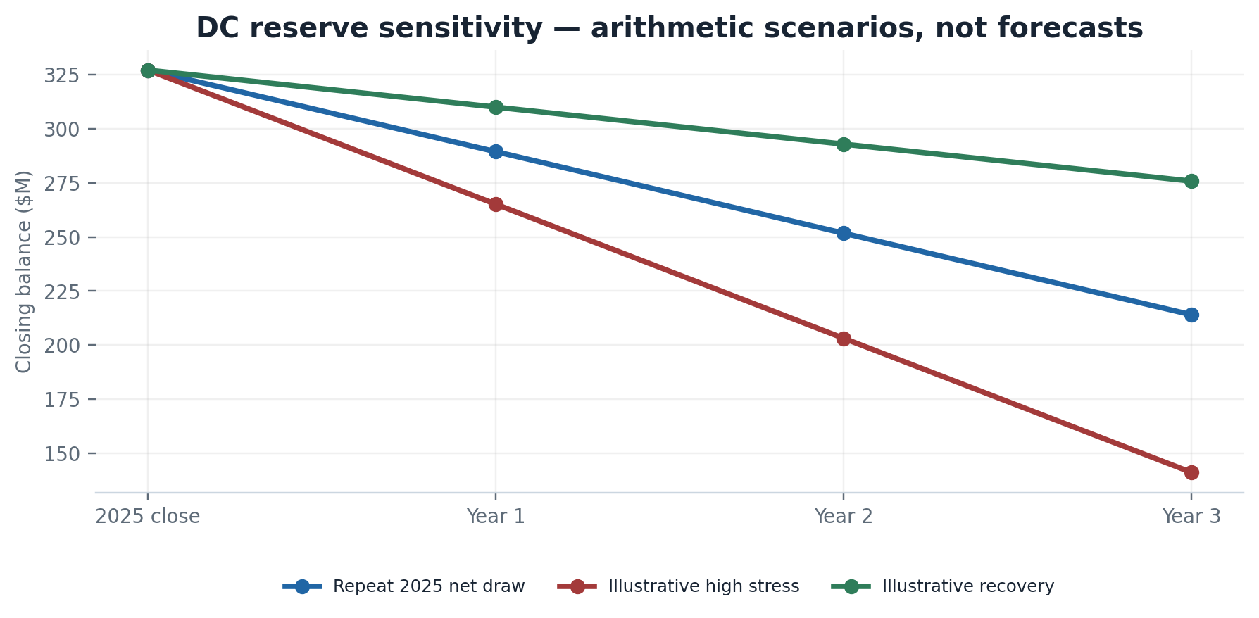
Figure 3. Arithmetic sensitivity from the 2025 closing balance. Assumptions below. Source: S10; calculations: Appendix D.
Scenario | Annual contribution | Annual disbursement | Net annual change | Year-3 balance
Repeat 2025 | $68.5M | $106.2M | −$37.7M | $214.0M
High stress | $54.8M (−20%) | $116.8M (+10%) | −$62.0M | $141.1M
Recovery | $89.1M (+30%) | $106.2M | −$17.1M | $275.8M

Do not call this a forecast
The scenarios hold all other factors constant and ignore project closures, new approvals, interest, debt issuance, exemption changes and timing. They show sensitivity to the observed 2025 cash-flow relationship; they do not predict insolvency.

SOURCE LOCK S09, S10
PART 4

Capital condition and project dossiers

4.1 Infrastructure renewal gap
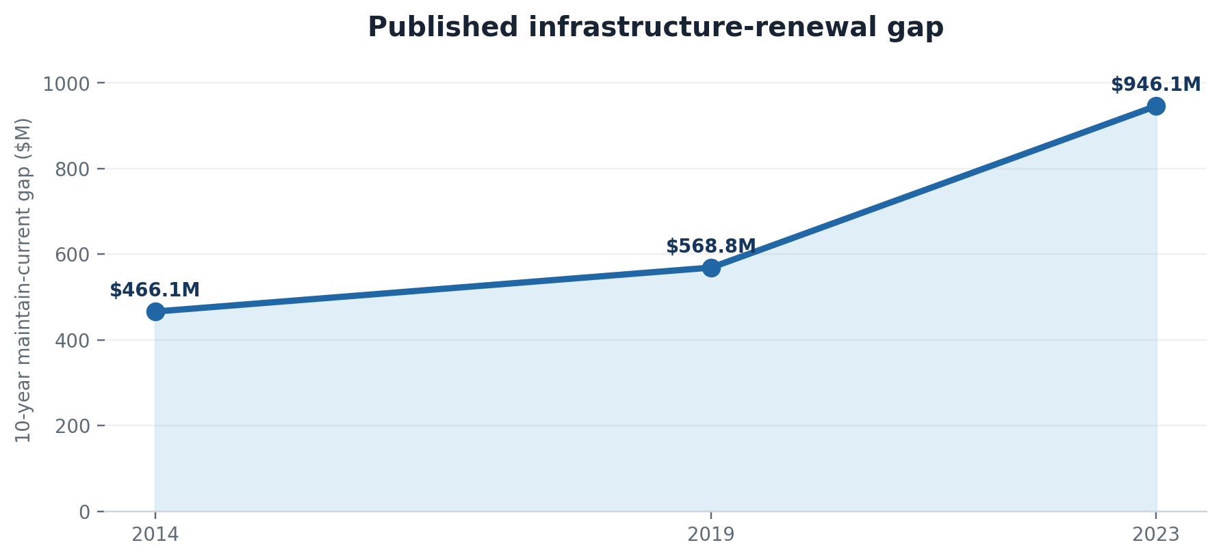
Figure 4. Ten-year maintain-current gap in each published asset-management cycle. Source: S04.
$28.5B  2023 replacement value  City-owned infrastructure | $946.1M  maintain-current gap  3.32% of replacement value | $1.378B  proposed-level gap  4.84% of replacement value

Correction: $946.1 million is 66.3% above the 2019 cycle’s $568.8 million and 103.0% above the 2014 cycle’s $466.1 million. The gap is a modeled renewal need—not proof of current failure, and not evidence of misspending.
SOURCE LOCK S04

4.2 Eight project and fund dossiers
Dossier | Authority / service | Public amount | What the record establishes | Unresolved test | Route
1 · Highbury Facility rebuild | LTC / capital service improvement | City project book: $301.9M; LTC phase figures imply about $321.7M | Two public budget vintages do not reconcile. 2025 LTC report says $5.0M did not get underway and carried to 2026. | Budget-vintage and delivery reconciliation | R1
2 · Roadmap to 3,000 | Housing Services | Project book: $78.0M | 2025 development report tracks 2,576 City-funded affordable units: 675 in progress, 1,360 in planning; stage for the balance is not stated in the summary. | Cost per completed/occupied affordable unit | R4
3 · Fanshawe campus grant | Economic development | Project GG1721-6: $20.75M | Named in the service-improvement capital book; end-to-end grant payment and outcome closeout not reproduced. | Agreement, payments, milestones, closeout | R1/R6
4 · Mud Creek Phase 2B | Stormwater | Total budget $24.720M; 2025 financing/spend lines reproduced | EA approved 2017; site work began 2025; construction continues into 2026. Award, change orders and physical completion not joined publicly. | Award, amendments, FAC, percent complete | R1/R2
5 · Springbank Dam | Environment / river project | Stage 1 estimate $14.6M; decommissioning budget up to $3M | Public record explains estimate changes, but final decommissioning cost and closeout were not located. | Final cost and closeout certificate | R1
6 · Wharncliffe/Horton | Transportation | $90M estimate; $39.6M funding gap reported Jan. 2026 | Unfunded at construction scale; no procurement expected yet. A smaller Wharncliffe line in the DC report is not the same project. | Updated estimate, financing plan, schedule | R1
7 · Operating contingency reserve | Corporate finance | 2018 balance $35.18M vs $96.59M policy target; 2024 audited contingency line $109.8M | Two accounting presentations are not proven to be the identical fund. Reconciliation is required before claiming recovery. | Fund mapping and policy-target calculation | R6
8 · Highway 401 / Highway 4 | Provincial transportation | No City capital cost established | MTO project; City endorsed municipal road closures. This lead is not a City-spending finding as framed. | None unless a different 401-adjacent project is specified | Closed

Capital conclusion
The named files show a recurring reconciliation gap—not a recurring overrun finding. Public sources often contain a budget, a status update or a financing line, but not a stable project ID tying all three to the award, amendments, forecast-at-completion and closeout.

SOURCE LOCK S01, S02, S09, S10, S25–S27
PART 5

Procurement compliance screen

5.1 Posted-award disclosure
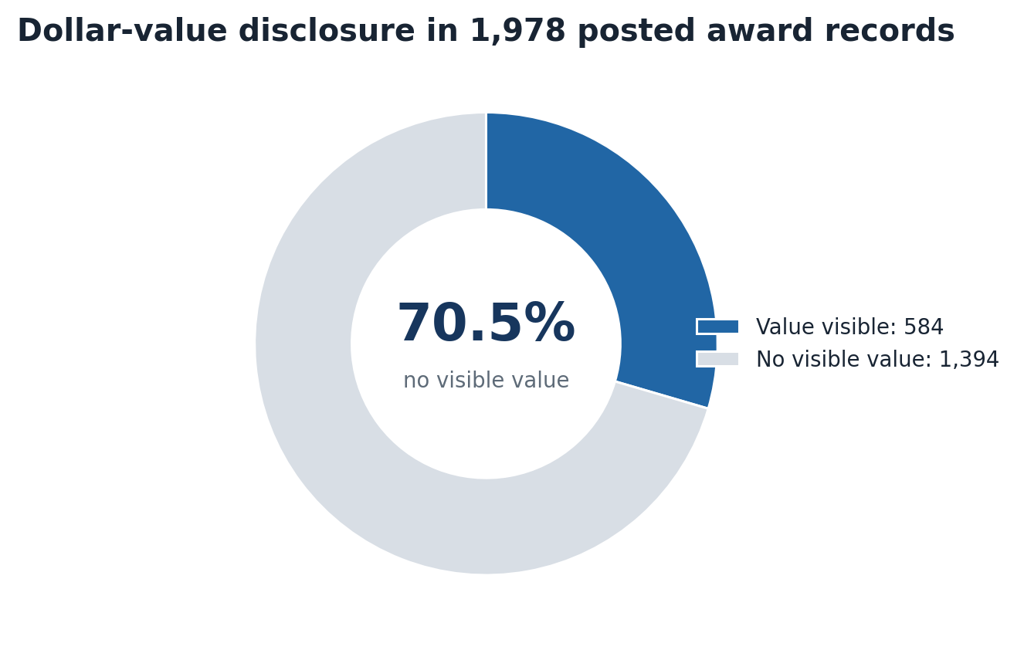
Figure 5. Posted-record visibility; not total procurement spend. Source: S05.
$1.022B  known-value total  584 records only | 71.6%  top-10 share  Of known-value awards | 94.3%  construction share  Of known-value dollars

The denominator is incomplete by design: 70.5% of parsed award records show no visible dollar value. The $1.022 billion known-value pool therefore cannot stand in for total City procurement. A descriptive HHI of 949 overall and 1,065 within construction is retained only as a sensitivity statistic for that disclosed slice; it is not an antitrust market definition or a finding of weak competition.
SOURCE LOCK S05 · 1,978 records; 1,073 high-confidence and 905 medium-confidence parser results.
REPRODUCIBILITY BOUNDARY The posted portal is the primary source, but the 1,978-row parser export and normalization workbook are not included in this publication package. Claims C010–C013 therefore remain derived / limited and should not be treated as independently replayed until the raw extract is released.

5.2 Policy-versioned tests
Test | Criterion | Result | Evidence / route
Policy in force | Awards before Oct. 1, 2025 use legacy policy; later actions use current policy. | PASS — version boundary identified. | S06, S07
Annual compliance review | Current policy requires an Annual Procurement Compliance Review. | PASS — 2025 review received Apr. 20, 2026. | S07
Biannual award reporting | Awards over $133,800 goods/services and $334,000 construction are disclosed. | PASS — May 27, 2026 report located. | S08
Limited tendering | Authority and exception must be supported under the applicable section. | PARTIAL — Council reports identify authority; portal export lacks a complete row-level flag. | R2
Contract amendments | Applicable approval limit, financing and Council trigger must be tested. | NOT TESTABLE PUBLICLY — no joined amendment history across awards. | R2
Bid spread / disqualification | Requires bid tabulations and evaluation records. | NOT TESTABLE PUBLICLY — award notices are insufficient. | R2
Vendor performance | Requires performance/termination/extension records. | NOT TESTABLE PUBLICLY — request supplied. | R2
Award-value publication | Public accountability test, not necessarily policy breach. | FAIL AS DISCLOSURE DESIGN — 70.5% no visible value in scraped set. | S05

5.3 Reproducible transaction test once records arrive
- Normalize award, vendor, project and contract identifiers; retain the original legal vendor name and corporate-family field separately.
- Assign the policy version using the decision date, not the scrape date.
- Join solicitation, bids received, responsive bids, evaluation, award, amendments, invoices, vendor-performance actions and Council authority.
- Test each exception against the exact policy clause and approval threshold in force.
- Publish exceptions as questions first; classify a breach only after procurement/legal confirmation and source review.
Procurement verdict
Public reporting proves a visibility problem and confirms that formal compliance reports exist. It does not permit a reliable award-by-award conclusion on sole source, bid spread, amendment approval or vendor performance. Request R2 is the missing input, not a request to invent a finding.

SOURCE LOCK S05–S08
PART 6

Workforce and productivity
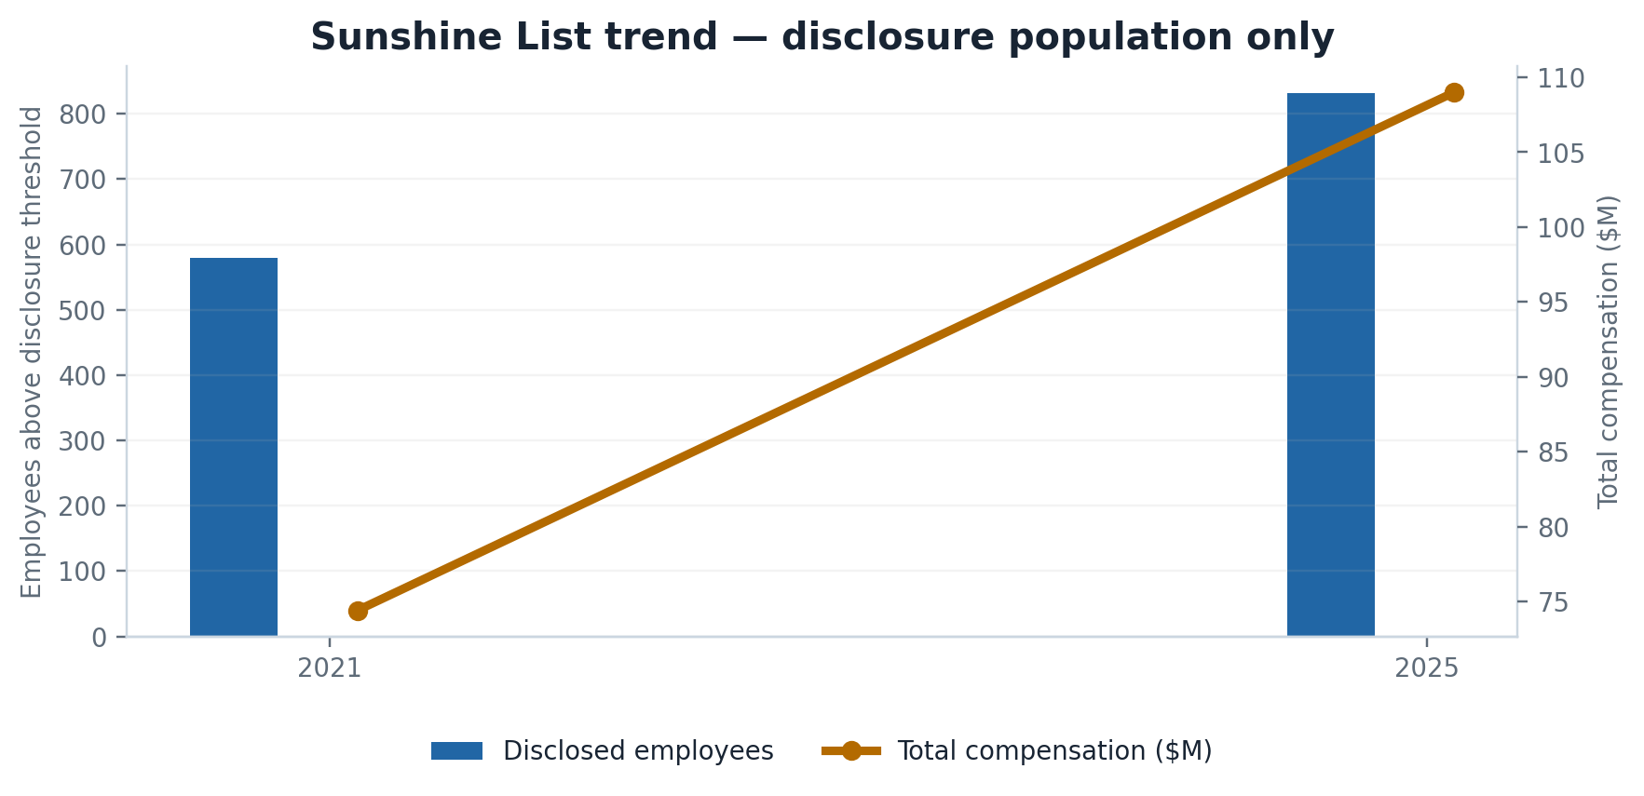
Figure 6. Ontario salary-disclosure population only. It is not City headcount. Source: S28.
579 → 831  disclosed employees  +43.5%, 2021–2025 | $74.4M → $109.0M  total compensation  +46.5% | $127.5K → $129.7K  average salary  +1.7% nominal

The public salary file is useful for one narrow question: how the population above Ontario’s disclosure threshold changed. It cannot answer total FTE growth, management ratio, spans, layers, vacancies, overtime, turnover, sick time, contracted labour, or output per FTE. Edition 3.0’s heuristic title buckets remain screening labels only.

6.1 Screening result
Heuristic title bucket | 2021 | 2025 | Change | Use
Management / supervisor | 167 | 293 | +75.4% | Records-request trigger; not official management count.
Professional / technical | 35 | 76 | +117.1% | Small-base, title-keyword screen.
Director / senior manager | 36 | 42 | +16.7% | Threshold population only.
Administrative / delivery | 9 | 23 | +155.6% | Small-base; do not generalize.
Executive leadership | 8 | 8 | 0.0% | Threshold population only.
Fire / emergency frontline | 310 | 325 | +4.8% | Not total fire complement.
Operations / field | 5 | 43 | +760.0% | Classification-sensitive; do not cite as workforce growth.

6.2 Finished productivity specification
Metric | Numerator | Denominator | Required source
Management ratio | Official management FTE | Total active FTE | HR complement extract
Span of control | Direct reports | People managers | Position hierarchy
Vacancy rate | Budgeted FTE less filled FTE | Budgeted FTE | Monthly complement
Overtime burden | Overtime hours/cost | Worked hours/payroll | Payroll by service
Turnover | Separations | Average headcount | HR movement file
Consultant substitution | Consulting/contract labour FTE-equivalent | Employee FTE | AP + contract + HR crosswalk
Service productivity | Volume and quality output | FTE and operating cost | Service KPI + finance + HR

Disposition: records-dependent
The workforce module is finished as an audit design and public-data screen. A numerical productivity conclusion would still be unsound without Request R3. The report therefore makes no claim that management grew faster than total staff on an official-complement basis.

SOURCE LOCK S28, R3
PART 7

Housing delivery and homelessness

7.1 Stage-separated 2025 housing ladder
Indicator | 2025 figure | Stage / scope | What it proves | What it does not prove
Residential building permits | 5,462 units | All permitted units | Record permit output; +47.62% over 2024. | Starts, completions, occupancy or affordability.
HAF year-2 permits | 4,284 vs 3,991 target | HAF measurement window | 293 above target (+7.3%). | Completed/occupied HAF homes or causal attribution.
City-funded affordable tracked | 2,576 units | Since late 2021 | City-funded pipeline count. | That all units are built or occupied.
In progress | 675 units | Subset of City-funded tracked | Project stage reported as in progress. | Uniform definition of start across projects.
In planning | 1,360 units | Subset of City-funded tracked | Pipeline planning stage. | Approval, construction or occupancy.
City-led HSH completed & occupied | 44 units | Highly supportive housing | Explicit completion and occupancy. | All supportive housing in London.
HSH tracked | 422 units | City/community/non-City funded | Combined tracked pipeline. | That all 422 are complete.

Affordable-housing reconciliation
The report states 2,576 City-funded affordable units tracked, including 675 in progress and 1,360 in planning. Those two stated subsets total 2,035, leaving 541 units in other stages not broken out in the summary. That remainder is a classification question, not an error finding.

The same report adds 693 affordable units constructed without City funding and 75 non-City-funded highly supportive units, producing 3,344 affordable units that will be or have been constructed since Council approved the Roadmap. The mixed future/past wording means the 3,344 total should not be restated as completions.
SOURCE LOCK S02, S03

7.2 Planning Act timeline exceptions
Application type | Within timeline | Average days | Screening note
OPA + zoning | 94% | 89 | Mostly within published timeline.
Zoning | 95% | 76 | Mostly within published timeline.
Removal of holding | 78% | 54 | Material exception; cause not shown.
Draft subdivision | 33% | 145 | Clearest published exception.
Site plan | 100% | 24 | Reported within timeline.

MNP’s June 2026 Subdivision Review Process Audit separately identified streamlining opportunities and a technology implementation target in Q1 2027. Council discussion indicated the technology work was funded and underway; process review work was targeted into 2027.
SOURCE LOCK S02, S23

7.3 Hubs: cost and outcome evidence
Operator | Dec. 2023–Dec. 2025 expenditure | Budget | Cost structure / screen
Youth Opportunities Unlimited | $2,979,974 | $3,301,300 | Staff $1,948,994; participant $241,416; operating $789,563.
Atlohsa | $4,248,275 | $4,236,292 | Staff $1,987,236; participant $445,839; operating $1,613,472; admin $201,728.

MNP’s supplemental report calculates approximate bed-day costs of $120.93 for shelter, $207.25 for Atlohsa and $362.34 for YOU. It also reports more than 100 people served, more than 40 stable-housing outcomes and an extreme-use case where emergency-department visits fell from 221 to 9. These figures strengthen the outcome evidence but still do not supply a location-by-location cohort, length-of-stay, housing-retention or critical-incident ledger.
Balanced finding
Stevenson’s September 2025 dissent correctly identified missing decision-grade outcome detail. The February 2026 supplement materially improves the cost breakdown and comparison, but it still does not close the project-level cohort and retention questions. Request R4 asks for the missing join.

SOURCE LOCK S17–S19, R4
PART 8

Community grants and CIP incentives

8.1 2024–2027 multi-year grant ledger
42  recipient organizations  Complete published list | $9.2M  four-year allocation  $2.3M per year | 164,003  people served / year  Average reported 2024–2025

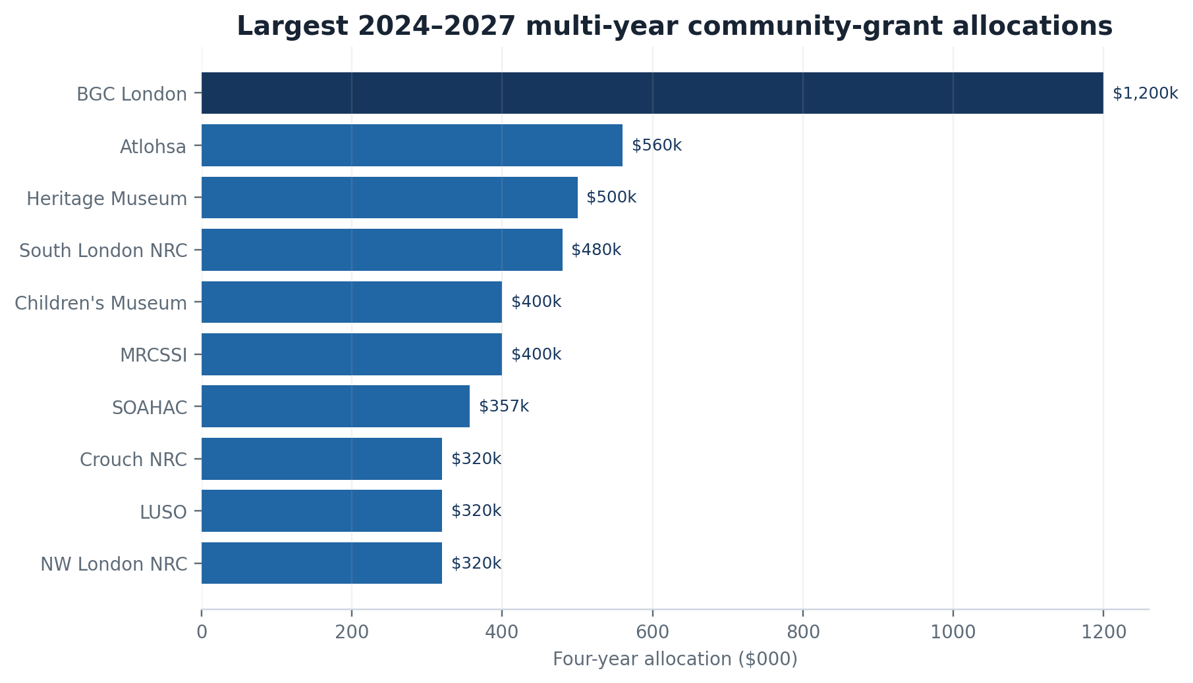
Figure 7. Four-year allocations; approval/allocation is not the same as cash paid. Source: S14.
The City’s June 2026 impact report says the multi-year program leveraged more than $50 million in other funding and that all listed projects were meeting expected outcomes at the time of reporting. Those are program-reported results; the ledger still needs agreement-level payments, evidence and closeout to support an independent outcome audit.
SOURCE LOCK S14, S15
Recipient | Four-year allocation
519Pursuit Umbrella Relief Programs Inc. | $45,760
Anova | $188,000
Atlohsa Family Healing Services | $560,000
Big Brothers Big Sisters of London and Area | $160,000
Boys' & Girls' Club of London | $1,200,000
Changing Ways | $200,000
Crouch Neighbourhood Resource Centre | $320,000
Glen Cairn Community Resource Centre | $240,000
Growing Chefs! Ontario | $180,000
L'Arche London | $102,000
Learning Disabilities Association of London Region | $60,000
LOLA (London Ontario Learning Apiary) Organization | $40,000
London & Middlesex Heritage Museum | $500,000
London Abused Women's Centre | $164,800
London Children's Museum | $400,000
London Community Chaplaincy | $200,000
London Cycle Link Association | $120,000
London Environmental Network | $170,000
London Food Coalition | $100,000
Low Income Family Empowerment / LIFE*SPIN | $104,000
LUSO Community Services | $320,000
Meals on Wheels London | $80,000
Museum of Ontario Archaeology | $200,000
Muslim Resource Centre for Social Support & Integration | $400,000
Nokee Kwe | $170,000
Northwest London Resource Centre | $320,000
Now for Tomorrow: South Sudanese Wellness Network | $140,000
Progressive Animal Welfare Services | $60,000
ReForest London | $240,000
South London Neighbourhood Resource Centre | $480,000
Southwest Ontario Aboriginal Health Access Centre | $356,700
St. John The Baptist Melkite Catholic Church | $60,000
St. Mark's (Diocese of Huron) | $8,740
Thames Talbot Land Trust | $120,000
The N'Amerind Friendship Centre | $240,000
The Reimagine Institute for Community Sustainability | $96,000
Type Diabeat It | $56,000
University Students' Council, Western University | $38,000
Urban Roots London | $120,000
WeBridge Community Services | $120,000
WIL Counselling and Training for Employment / Immploy | $200,000
Youth Opportunities Unlimited | $320,000
TOTAL — 42 recipients | $9,200,000

8.2 MNP control findings and current status
Observation | Risk | Management action | Due / status
No documented threshold or criteria translates final application scores into funding amounts; project viability is considered for partial awards. | Inconsistent awards or perceived subjectivity. | Enhance administrative procedures and bring changes through the comprehensive review. | Q4 2027 · On track; procedures enhanced for 2026 annual stream.
No mandatory requirement for panel members to enter scoring rationale in SmartSimple; strategic areas may overlap other City funding. | Missing audit trail, appeal difficulty, possible crowd-out. | Require/strengthen rationale and consider targeted support where no other municipal source exists. | Q4 2027 · On track.

SOURCE LOCK S16, S24

8.3 2025 annual stream — complete list
Organization | Stream | Allocation
Urban Roots London | Capital | $37,890
London Environmental Network | Innovation | $25,580
Boomerz Boxing | Grassroots | $28,420
Queer Intersections | Grassroots — year 2 | $28,420
London InterCommunity Health Centre | Innovation | $22,450
AfroBiome Foods Incorporated | Grassroots | $22,830
Youth Coalition Combating Islamophobia | Grassroots | $14,210
The Iraqi Canadian Society | Innovation | $10,680
Cameroon Association of London Ontario | Innovation | $12,000
Jazz Association of London ON | Innovation | $10,620
BlendIN | Grassroots | $10,000
Black Community Employment & Empowerment Service | Innovation | $10,000
Wortley Pride | Grassroots | $3,900
Kensington Village Association | Grassroots — year 2 | $5,000
AEL FC Canada | Innovation | $5,000
Pollinator Pathways Project | Grassroots | $3,000
TOTAL — 16 organizations |  | $250,000

SOURCE LOCK S14

8.4 CIP incentive sample and remaining boundary
Recipient | Program | Amount | Verified status
LJM Developments (London) Inc. | Brownfield CIP — 359 Wellington Rd. | $2,100,000 | Approved Feb. 19, 2025; conditions precede payment.
Youth Opportunities Unlimited | Residential DC grant — 340 Richmond St. | $14,895 | Council directed processing Oct. 27, 2020; payment not independently verified.

CIP status
The public sample is verified but not a complete beneficiary ledger. Request R6 seeks all approvals, payments, conditions, outputs, closeout and clawback status, including Office-to-Residential and other HAF-adjacent incentives.

SOURCE LOCK S29, S30, R6
PART 9

Service-specific performance modules

9.1 Transit — built
17.5M  2025 conventional rides  Down from 2024 peak | 24.4  rides / service hour  2025 conventional | 46%  on-time satisfaction  Highest-priority attribute

LTC reports that all 2025 ridership metrics fell short of budget, primarily because tuition-pass enrollment declined more than anticipated. Conventional service added 18,000 hours (+2.5%) and overall satisfaction was 68%. The 2025 operating program was about $118 million; actual funding shares were 55% City, 38% transportation/operating revenue and 7% provincial gas tax.
Metric | 2025 LTC | Comparator / interpretation
Conventional ridership | 17.5M | 2024 peer average 13.2M; LTC ranked 5th in 2024.
Rides per capita | 38.2 | Flat/slight decline signals service/ridership not keeping pace with population.
Rides per service hour | 24.4 | 2024 peer average 25.0; LTC ranked 6th.
Operating cost per ride | $5.62 | 2024 peer average $6.05.
Municipal cost per ride | $2.75 | 2024 peer average $3.81.
Specialized ridership | 356,667 | 6.0% below budget; 1.9 rides/hour vs 2.0 budget.
Specialized satisfaction | 96% overall | All listed service characteristics ≥80%.
Deferred 2025 capital | $33.9M | Highbury $5.0M, zero-emission pilot $26.0M, fleet radio $0.6M carried forward.

SOURCE LOCK S31

9.2 Police — built
$186.7M  2025 net cost  In line with approved budget | 238,293  9-1-1 calls answered  Communications Centre | 77%  strategic deliverables complete  288 of 375

The 2025 LPS annual report states that Priority 1 and Priority 3 response times improved, officers completed more than 34,000 targeted patrol visits and dedicated over 22,000 hours to data/community-identified locations. The published summary does not provide the same detailed 90th-percentile response-time table used in the 2024 report; the underlying 2025 KPI table should be requested for trend testing.
SOURCE LOCK S32

9.3 Remaining services — finished availability matrix
Service | Public baseline located | Required performance spine | Route
Fire | 2025 Fire Master Plan; >400 personnel and >13,000 alarms/year baseline. | Annual incidents by type, 90th-percentile turnout/travel/total response, staffing compliance, loss, inspections. | R5
Water | 2026 operating budget $111.050M; capital plan $707M; annual water-quality reporting page. | Volume, breaks, leakage, boil-water/adverse events, complaint/restoration times, unit cost. | R5
Wastewater/stormwater | 2026 operating budget $142.567M; capital plan $1.469B; 2025 stormwater performance link. | Influent/effluent, bypasses, overflows, energy, unit cost, flood calls, regulatory exceedances. | R5
Roads / traffic | Asset inventories and budget/project reporting available. | Lane-km condition, pothole response, winter standard compliance, construction delay, unit cost. | R5
Recreation / parks | Annual master-plan reports and service plans available. | Facility utilization, waitlists, subsidy per visit, closures, field/ice condition, geographic access. | R5
Real estate | Scattered acquisition/disposition and project records. | Property inventory, utilization, vacancy, carrying cost, appraisal vs transaction, lease revenue. | R5
Fleet | Capital replacements and service-plan material. | Availability, age, downtime, maintenance cost/km, fuel/energy, preventable incidents. | R5
IT / digital | Project/business-case reporting, no joined portfolio outcomes. | Portfolio budget/FAC, uptime, incidents, licensing, project benefits, contractor reliance. | R5
Legal / insurance | Financial-statement liabilities and scattered reports. | Claims by type, reserve, settlement, legal spend, cycle time, recoveries. | R5
Economic-development incentives | CIP and grant approvals exist. | Approval/payment/output/tax-base/occupancy/jobs ledger with counterfactual caveat. | R6

Service-module verdict
Transit and police are now evidence-built. The other services no longer sit as vague “future work”: each has a defined KPI spine, known public baseline and exact request route. Until the underlying series arrives, the report makes no cross-service productivity ranking.

SOURCE LOCK S01, S27, S31–S35, R5
PART 10

Strategy-to-output traceability and internal-audit crosswalk

10.1 Strategy → input → output → outcome
Program | Strategy / target | Public input | Public output | Outcome evidence | Gap
CEAP | Net-zero community emissions by 2050; 200 actions. | Partial business-case funding; $45.5M requested over four years. | Dashboard statuses and progress reports. | Emissions/progress indicators exist, but attribution is broad. | Audit found broad/descriptive design and limited funding for many actions.
Community grants | Strategic-plan alignment. | $9.2M multi-year; annual streams. | Organizations/projects and people served. | Reported leverage and project outcomes. | Score-to-award rule and rationale controls remain open.
Affordable housing | Roadmap to 3,000. | Municipal capital/program funding. | 2,576 City-funded units tracked. | 44 City-led HSH units explicitly completed/occupied. | Stable project-stage and cost-per-occupied-unit join missing.
Transit | Accessible, reliable, affordable mobility. | $118M operating program; service hours. | Rides, service hours, route changes. | Satisfaction, cost/ride, peer data. | On-time satisfaction remains low; population growth test flagged by LTC.
CIPs | Revitalization and private investment. | Incentive approvals. | Projects receiving incentives. | Project-level outcomes not consolidated publicly. | MNP found limited project-level outcome monitoring.

SOURCE LOCK S02, S14–S16, S20–S22, S31

10.2 CEAP audit — what changed
MNP’s June 17, 2026 CEAP final report lists 17 observations and recommendations. Searchable primary-source text identifies two central issues: the plan’s broad/descriptive nature complicates measurement and Council reporting, and many actions have limited allocated funding. The audit notes a $45.5 million four-year CEAP business-case request; only selected components were funded. Management responses should be tracked by observation, accountable owner and due date rather than summarized as one program status.
Public dashboard is necessary but not sufficient
The live CEAP dashboard lists all 200 actions with status and indicators. A status is not an outcome. Each action still needs a baseline, target, annual value, owner, cost, causal limits and evidence link.

SOURCE LOCK S21, S22, S36

10.3 Internal-audit crosswalk
Audit / review | Risk / volume | Core issue | Status at lock | Ledger link
Housing Development Projects — lessons learned | High | Property-manager input; tenant-mix implications; baseline financial sustainability; reserve funding. | Closed after Dec. 1, 2025 management report. | Capital dossiers; housing
Community Grants VfM | 2 medium | Score-to-funding rule; mandatory rationale; target areas without overlapping municipal funding. | On track · Q4 2027. | Grants
Homelessness VfM | 2 medium | Hubs governance/outcomes; supplemental cost-benefit detail. | Follow-up dashboard plus Feb. 2026 supplement. | Housing / Hubs
ARAO Audit | 5 medium | Use/governance of ARAO framework and Equity Tool. | Tracked in follow-up dashboard; detailed actions remain source-specific. | Strategy / governance
Performance Measurement | Final Nov. 10, 2025 | Corporate performance framework and implementation tools tied to strategic-plan renewal. | Management targets span Q1–Q4 2026; framework completion Q4 2026. | All modules
Community Improvement Plans | 10 observations | Outcome monitoring; consolidated mapping to incentives; forecasting; awareness/communication. | Actions target Q3 2026 through Q2 2027. | CIPs / incentives
Subdivision Review Process | Final Jun. 17, 2026 | Streamlining, technology and information-sharing; jurisdictional scan. | Technology target Q1 2027; broader review timing into 2027. | Housing / planning
CEAP | 17 observations | Plan measurability, funding, indicators, reporting and action ownership. | Final received Jun. 17, 2026; action-level follow-up needed. | Strategy / climate
Continuous Improvement | 2026 plan | Efficiency/effectiveness of the program. | Planned Oct. 7, 2026 at Feb. plan date. | Future update
Privacy | 2026 plan | Privacy governance and controls. | Planned Dec. 9, 2026 at Feb. plan date. | Future update

10.4 Follow-up quality screen
At the February 25, 2026 follow-up cycle, MNP reported ten recommendations reviewed: three closed and seven on track. A strong public dashboard should show the original action, original/revised due dates, accountable owner, evidence submitted, auditor validation and closure rationale. Current summaries are useful, but not always decision-grade at that granularity.
SOURCE LOCK S20–S24
PART 11

Evidence-safe reforms and implementation sequence
# | Reform | Minimum fields | Cadence | Home
1 | Major-project reconciliation ledger | Original authority, baseline budget/schedule, current FAC, award, amendments, commitments, payments, physical progress and closeout under one project ID. | Quarterly | Capital dashboard
2 | Procurement award + amendment ledger | Vendor, value, solicitation, bids, authority, policy version, limited-tendering reason, amendments and performance status. | Monthly + biannual certification | Open data
3 | Grant/CIP outcomes ledger | Score, rationale, requested/approved/paid, agreement milestones, output, outcome, closeout and clawback. | Annual + live status | Program pages
4 | Housing cohort pipeline | Application → permit → start → completion → occupancy → affordability monitoring under stable project/address IDs. | Monthly | Housing dashboard
5 | Workforce complement spine | Budgeted/filled FTE, vacancies, layers, spans, overtime, turnover, leave and contractor equivalent by service. | Quarterly | Corporate performance
6 | Service KPI dictionary | Baseline, target, actual, cost, quality, equity, source, owner and revision history for every reported KPI. | Annual dictionary; quarterly data | Performance portal
7 | Internal-audit action register | Full observation, management action, owner, dates, evidence and auditor closure rationale. | Each Audit Committee cycle | Audit page

90-day sequence
Window | Action | Deliverable
Days 0–30 | File R1–R6; ask for fee estimates, index first, rolling production and machine-readable native formats. | Acknowledgements, custodians, search terms, production schedule.
Days 31–60 | Normalize identifiers; rebuild joins; send factual clarification questions before classifying exceptions. | Project/procurement/grant/housing master tables.
Days 61–90 | Publish exceptions with City responses, document versions and reproducible calculations. | Edition 5.1 transaction supplement; no change to verified baseline without source.

Priority order
1) capital project controls and amendments; 2) procurement bid/amendment join; 3) housing/grant project-level outcomes; 4) workforce and service productivity. This ordering targets the largest risk of public misinterpretation first.

APPENDIX A

Filing-ready records-request package
These requests are drafted for the City of London under Ontario’s Municipal Freedom of Information and Protection of Privacy Act (MFIPPA). They intentionally ask for existing records, native exports and field definitions—not for staff to create analysis. Before filing, confirm the City’s current form, fee and submission channel.
Common instructions for all six requests
Provide records electronically in native machine-readable format where available (CSV/XLSX/database export; searchable PDF for documents). Include a record index and data dictionary. Apply severance rather than withholding whole records. Identify each exemption relied upon. If volume is high, provide an index and fee estimate first, then rolling production. Exclude personal information not needed for the audit.

RECORDS REQUEST R1

Major capital project controls
Custodian(s) | Period | Preferred format
Environment & Infrastructure; Finance; LTC for Highbury | 2014-01-01 to 2026-08-20 | Native CSV/XLSX/export + searchable PDFs + index/data dictionary

Records requested
- Highbury Facility rebuild; Mud Creek East Branch Phase 2; Springbank Dam decommissioning/Back to the River Stage 1; Wharncliffe Road South/Horton intersection; Fanshawe campus grant project GG1721-6; and every City capital project with current total budget ≥$10M.
- Project charter/business case; original and current approved scope, budget and schedule; all budget transfers; baseline and current forecast-at-completion; monthly/quarterly project-control reports; risk/issue/change logs; percent complete; substantial-performance and closeout records.
- Award, consultant and contractor identifiers; commitments, invoices-to-date and retainage totals; funding-source history by project.

Required fields / structure
Stable project ID, project name, sponsor, manager, budget vintage, original/current budget, committed, actual, FAC, schedule baseline/current, percent complete, change ID/value/reason/approval, risk rating, closeout date.

Search and processing direction
- Search shared drives, project systems, ERP/financial systems, procurement systems, records-management repositories and official email accounts of the responsible project/program managers where responsive records are not in the systems of record.
- Provide a list of custodians, systems searched, date search completed and any retention/destruction schedule affecting the period.
- If a field is not held, mark it 'not held' rather than leaving it blank; if records are withheld, identify the MFIPPA exemption and number of records/pages affected.
- Please contact the requester before incurring fees above $100 and provide options to narrow by project, year or record type.

RECORDS REQUEST R2

Procurement bids, exceptions and amendments
Custodian(s) | Period | Preferred format
Procurement & Supply; Finance; project sponsors | 2017-01-01 to 2026-08-20 | Native CSV/XLSX/export + searchable PDFs + index/data dictionary

Records requested
- Row-level export for all solicitations/awards in the Bids and Tenders Contract Awards/Annual Statistics population.
- Solicitation and award IDs, vendor legal name, bids received, responsive bids, bid prices or evaluated price, evaluation score, disqualification reason, award value/date, procurement method, policy version and exception/limited-tendering clause.
- All amendments/change orders, original and revised contract value, approval authority/date, Council report reference, extension/renewal/termination and vendor-performance actions.

Required fields / structure
One row per award and one row per amendment, linked by contract ID; include code lists and cancelled/no-award records.

Search and processing direction
- Search shared drives, project systems, ERP/financial systems, procurement systems, records-management repositories and official email accounts of the responsible project/program managers where responsive records are not in the systems of record.
- Provide a list of custodians, systems searched, date search completed and any retention/destruction schedule affecting the period.
- If a field is not held, mark it 'not held' rather than leaving it blank; if records are withheld, identify the MFIPPA exemption and number of records/pages affected.
- Please contact the requester before incurring fees above $100 and provide options to narrow by project, year or record type.

RECORDS REQUEST R3

Workforce complement and productivity
Custodian(s) | Period | Preferred format
People Services; Finance; all service areas | 2019-01-01 to 2026-08-20 | Native CSV/XLSX/export + searchable PDFs + index/data dictionary

Records requested
- Year-end and monthly budgeted/filled FTE by service, division, job family, employment status, bargaining unit and management layer.
- Position hierarchy with anonymized position IDs and supervisor position IDs; vacant positions and vacancy days; hires, separations and transfers.
- Regular/overtime hours and cost; sick/leave hours; contractor/temporary agency and consulting labour cost with FTE-equivalent if held; service-volume KPIs used internally.

Required fields / structure
No employee names required. Preserve anonymized position IDs across periods so spans, layers and movements can be calculated.

Search and processing direction
- Search shared drives, project systems, ERP/financial systems, procurement systems, records-management repositories and official email accounts of the responsible project/program managers where responsive records are not in the systems of record.
- Provide a list of custodians, systems searched, date search completed and any retention/destruction schedule affecting the period.
- If a field is not held, mark it 'not held' rather than leaving it blank; if records are withheld, identify the MFIPPA exemption and number of records/pages affected.
- Please contact the requester before incurring fees above $100 and provide options to narrow by project, year or record type.

RECORDS REQUEST R4

Housing and homelessness cohort ledger
Custodian(s) | Period | Preferred format
Housing & Community Growth; Social & Health Development | 2021-01-01 to 2026-08-20 | Native CSV/XLSX/export + searchable PDFs + index/data dictionary

Records requested
- Project-level ledger for Roadmap to 3,000, HAF, Office-to-Residential, Hubs and highly supportive housing.
- Stable project/address ID; application, approval, permit, start, completion and occupancy dates; total/affordable/supportive units; affordability term; municipal/federal/provincial contribution approved/paid; agreement and operator.
- For Hubs: anonymized episode/cohort outcomes by site—entry/exit, length of stay, housing destination, 6/12-month retention if held, critical incidents and service utilization—plus denominator definitions.

Required fields / structure
Sever personal information and provide aggregate/anonymized rows. Identify stage definitions and as-of dates.

Search and processing direction
- Search shared drives, project systems, ERP/financial systems, procurement systems, records-management repositories and official email accounts of the responsible project/program managers where responsive records are not in the systems of record.
- Provide a list of custodians, systems searched, date search completed and any retention/destruction schedule affecting the period.
- If a field is not held, mark it 'not held' rather than leaving it blank; if records are withheld, identify the MFIPPA exemption and number of records/pages affected.
- Please contact the requester before incurring fees above $100 and provide options to narrow by project, year or record type.

RECORDS REQUEST R5

Service performance data spine
Custodian(s) | Period | Preferred format
Fire; Water; Wastewater; Roads; Recreation; Fleet; IT; Real Estate; Legal/Risk | 2019-01-01 to 2026-08-20 | Native CSV/XLSX/export + searchable PDFs + index/data dictionary

Records requested
- Annual/monthly KPI exports and data dictionaries used for management, business plans, dashboards or Council reporting.
- Budget/actual cost, volume, quality, timeliness, reliability, utilization, complaints and equity/geography dimensions for each service.
- Fire response components; water breaks/quality/leakage; wastewater bypass/overflow/compliance; roads condition/response/winter; recreation utilization/waitlists; fleet availability/cost; IT uptime/incidents/projects; real-estate utilization; claims/legal spend.

Required fields / structure
Provide target, actual, numerator, denominator, owner, source system, revision date and any discontinuity notes.

Search and processing direction
- Search shared drives, project systems, ERP/financial systems, procurement systems, records-management repositories and official email accounts of the responsible project/program managers where responsive records are not in the systems of record.
- Provide a list of custodians, systems searched, date search completed and any retention/destruction schedule affecting the period.
- If a field is not held, mark it 'not held' rather than leaving it blank; if records are withheld, identify the MFIPPA exemption and number of records/pages affected.
- Please contact the requester before incurring fees above $100 and provide options to narrow by project, year or record type.

RECORDS REQUEST R6

Grants, CIP incentives and contingency mapping
Custodian(s) | Period | Preferred format
Community Development & Grants; Planning; Finance | 2020-01-01 to 2026-08-20 | Native CSV/XLSX/export + searchable PDFs + index/data dictionary

Records requested
- Every Community Grant and CIP/incentive application, including multi-year, annual, Brownfield, Office-to-Residential and Residential DC programs.
- Applicant/recipient, project, amount requested/scored/approved/committed/paid, panel scores and rationale, agreement, milestones, reports, outputs/outcomes, monitoring, closeout, repayment/clawback and status.
- Chart-of-account/fund mapping that reconciles the 2018 Operating Budget Contingency Reserve target to the 2024 audited 'Contingencies' reserve line and subsequent policy-target calculations.

Required fields / structure
One recipient-project-year row plus payment/milestone tables linked by agreement ID; include withdrawn/declined projects and reason codes.

Search and processing direction
- Search shared drives, project systems, ERP/financial systems, procurement systems, records-management repositories and official email accounts of the responsible project/program managers where responsive records are not in the systems of record.
- Provide a list of custodians, systems searched, date search completed and any retention/destruction schedule affecting the period.
- If a field is not held, mark it 'not held' rather than leaving it blank; if records are withheld, identify the MFIPPA exemption and number of records/pages affected.
- Please contact the requester before incurring fees above $100 and provide options to narrow by project, year or record type.
APPENDIX B

Claim Verification Register
This register logs the material claims used for outreach. “Derived” means arithmetic is reproduced in Appendix D. “Limited” means the claim is valid only at the stated denominator or reporting stage. The three short-form closure claims are: C046, the CEAP audit contains 17 observations/recommendations (S22); C047, the February 2026 follow-up reviewed 10 actions—three closed and seven on track (S24); and C048, all twelve original asks have final dispositions—eight built and four routed to filing-ready records requests (Appendix E).
ID | Material claim | Status | Source | Guardrail
C001 | 2026 tax-supported operating expenditure is $1.467820B. | Verified | S01 | Budget authority; not actual.
C002 | 2026 tax-rate increase is 3.4%. | Verified | S01 | Rate impact, not levy growth.
C003 | Three 10-year capital plans total $3.588B, $707M and $1.469B. | Verified | S01 | Keep support types separate.
C004 | 2024 actual expenses were below budget in 8 of 9 PSAB functions. | Derived | S11 | Broad functions only.
C005 | Social housing was 28.2% below budget in 2024. | Derived | S11 | Cause not established.
C006 | 2025 PSAB annual surplus was $463.734M vs $281.085M budget. | Verified | S12 | Not tax-supported cash surplus.
C007 | 2025 PSAB surplus variance was $182.649M (+65.0%). | Derived | S12 | Arithmetic only.
C008 | 2023 maintain-current infrastructure gap was $946.1M. | Verified | S04 | Modeled 10-year gap.
C009 | Infrastructure gap rose 66.3% from 2019 and 103.0% from 2014. | Derived | S04 | Cycle-to-cycle published values.
C010 | 70.5% of 1,978 scraped award records had no visible value. | Derived / limited | S05 | Scraped posted population only.
C011 | Known-value awards total $1.0223B. | Derived / limited | S05 | Excludes unknown-value records.
C012 | Top ten vendors represent 71.6% of known-value awards. | Derived / limited | S05 | Not total procurement; no parent normalization.
C013 | Known-value HHI is 949 overall and 1,065 construction. | Derived / limited | S05 | Descriptive statistic; not market concentration.
C014 | Current procurement policy took effect Oct. 1, 2025. | Verified | S06 | Legacy policy applies earlier.
C015 | 2025 Annual Procurement Compliance Review was received Apr. 20, 2026. | Verified | S07 | Existence does not prove every award compliant.
C016 | May 2026 biannual report threshold is $133,800 goods/services and $334,000 construction. | Verified | S08 | Threshold is report scope.
C017 | 2025 DC contributions were $68.5M and disbursements $106.2M. | Verified | S10 | All eleven funds combined.
C018 | 2025 DC closing balance was $327.1M. | Verified | S10 | Not uncommitted cash.
C019 | Repeat-draw scenario produces $214.0M in year 3. | Derived | S10 | Sensitivity, not forecast.
C020 | Sunshine List headcount rose 579 to 831 from 2021 to 2025. | Derived / limited | S28 | Above-threshold disclosure population only.
C021 | Average disclosed salary rose 1.7% nominal. | Derived / limited | S28 | Not real wage; not all staff.
C022 | 5,462 residential units received permits in 2025. | Verified | S02 | Not completions.
C023 | HAF year-2 permits were 4,284 vs 3,991 target. | Verified | S03 | HAF measurement window.
C024 | 2,576 City-funded affordable units were tracked by Dec. 31, 2025. | Verified | S02 | Mixed pipeline stages.
C025 | 675 affordable units were in progress and 1,360 in planning. | Verified | S02 | Stage definitions not reproduced.
C026 | 44 City-led HSH units were completed and occupied. | Verified | S02 | Specific subset.
C027 | 422 HSH units were tracked in 2025. | Verified / limited | S02 | Not all complete.
C028 | Draft subdivisions were within timeline 33% of the time, avg 145 days. | Verified | S02 | Cause not established.
C029 | 42 recipients total exactly $9.2M in 2024–2027 grants. | Verified / derived | S14 | Allocation, not payment.
C030 | Grant recipients reported average 164,003 people served/year. | Verified | S15 | Program-reported metric.
C031 | Grants reportedly leveraged >$50M. | Verified | S15 | Not independently audited here.
C032 | MNP found no documented score-to-award threshold. | Verified | S16 | Medium-risk observation.
C033 | MNP found no mandatory panel scoring rationale in SmartSimple. | Verified | S16 | Medium-risk observation.
C034 | Both grant actions are on track for Q4 2027. | Verified | S24 | Status at evidence lock.
C035 | YOU hub spend was $2.980M vs $3.301M budget. | Verified | S19 | Dec. 2023–Dec. 2025.
C036 | Atlohsa spend was $4.248M vs $4.236M budget. | Verified | S19 | Dec. 2023–Dec. 2025.
C037 | MNP reported >100 served and >40 stable housing outcomes. | Verified | S18/S19 | Not fully broken down by site/cohort.
C038 | LTC reported 17.5M conventional rides in 2025. | Verified | S31 | Annual report.
C039 | LTC 2025 rides per service hour were 24.4. | Verified | S31 | Conventional service.
C040 | On-time performance satisfaction was 46%. | Verified | S31 | Survey metric, ±3.7% margin.
C041 | LTC carried $33.9M of unstarted 2025 capital into 2026. | Verified | S31 | Not proof of failed projects.
C042 | LPS 2025 net cost was $186.7M. | Verified | S32 | In line with approved budget.
C043 | LPS answered 238,293 9-1-1 calls. | Verified | S32 | Communications metric.
C044 | LPS completed 288 of 375 strategic deliverables. | Verified / derived | S32 | 77%, second year of plan.
C045 | CIP audit contains 10 observations. | Verified | S20 | Final Feb. 12, 2026.

APPENDIX C

Official source register
ID | Source | Use
S01 | City of London — 2026 Annual Budget Update | Budget and capital plans
S02 | City of London — 2025 Annual Development Report | Permits, timelines, affordable/HSH pipeline
S03 | City of London — London exceeds HAF target (2025) | HAF target and permit result
S04 | City of London — Corporate Asset Management | 2023 CAM plan and gap context
S05 | City Bids and Tenders portal — Contract Awards / Annual Statistics | 1,978-record procurement extraction
S06 | City of London — current Procurement of Goods and Services Policy | Policy effective Oct. 1, 2025
S07 | 2025 Procurement Compliance Report | Annual compliance review
S08 | Bi-Annual Procurement Report, May 27 2026 | Awards over reporting thresholds
S09 | 2024 Annual Report on DC Reserve Funds | 2024 reserves, shortfall, project tables
S10 | 2025 Annual Report on DC Reserve Funds | 2025 contribution, disbursement, balance and debt
S11 | City financial reporting page — 2024 audited statements | 2024 functional budget/actual and condition
S12 | 2025 Consolidated Financial Statements | 2025 audited annual surplus
S13 | 2025 Consolidated Financial Report presentation | Variance explanation
S14 | City of London Community Grants Program | 42 multi-year and 16 annual allocations
S15 | Community Grants Impact Report 2024–2025 | People served, leverage and reported outcomes
S16 | Internal Audit Follow-up — grants observations | Grant control findings and status
S17 | Susan Stevenson letter re Hubs VfM audit | Primary-source dissent and questions
S18 | Housing & Homelessness VfM final report | Hub outcomes and audit findings
S19 | Housing & Homelessness VfM supplemental | Operator cost breakdown and comparisons
S20 | Community Improvement Plans Audit | 10 observations and management actions
S21 | Performance Measurement Audit | Corporate framework recommendations
S22 | CEAP Audit final report | 17 observations/recommendations
S23 | Subdivision Review Process Audit | Streamlining and technology
S24 | Audit Committee Feb. 25, 2026 agenda / follow-up dashboard | Audit plan, recommendations and status
S25 | 2024–2033 Tax-Supported Project Detail Records | Named service-improvement projects
S26 | City committee and council meeting portal | Project and authorization records
S27 | 2026 Growth Management Implementation Strategy | Growth-infrastructure timing and reserve context
S28 | Ontario Public Sector Salary Disclosure | 2021–2025 City of London disclosure rows
S29 | PEC minutes — LJM brownfield approval | CIP approval status; meeting portal used where a stable deep link was not verified
S30 | City Council minutes, Oct. 27 2020 | YOU residential DC grant direction; meeting portal used where a stable deep link was not verified
S31 | London Transit Commission — 2025 Annual Report | Transit service, finance and capital metrics
S32 | London Police Service Board — 2025 Annual Report summary | Police performance and finance
S33 | City of London — Fire Department | Fire service baseline
S34 | City of London — Water system | Annual water reporting
S35 | City of London — Sewers and wastewater | Wastewater/stormwater reports
S36 | City of London — CEAP dashboard and reports | 200 actions and reporting links
S37 | City of London contact/council roster | Current council role check at lock date
APPENDIX D

Reproducible calculations and caveats
Measure | Formula | Result | Caveat
Infrastructure gap, 2019→2023 | (946.1 − 568.8) ÷ 568.8 | 66.33% | Rounded to 66.3%.
Infrastructure gap, 2014→2023 | (946.1 − 466.1) ÷ 466.1 | 102.98% | Rounded to 103.0%.
2025 PSAB surplus variance | 463.734 − 281.085 | $182.649M | PSAB annual surplus.
2025 PSAB surplus variance % | 182.649 ÷ 281.085 | 64.98% | Rounded to 65.0%.
Procurement no-value rate | 1,394 ÷ 1,978 | 70.475% | Rounded to 70.5%; scraped records.
Top-10 known-value share | 732.1 ÷ 1,022.3 | 71.61% | Rounded to 71.6%.
Construction known-value share | 964.1 ÷ 1,022.3 | 94.31% | Rounded to 94.3%.
DC 2025 net change | 68.5 − 106.2 | −$37.7M | Contribution less disbursement.
DC high-stress net change | 68.5×0.8 − 106.2×1.1 | −$62.02M | Rounded to −$62.0M.
DC recovery net change | 68.5×1.3 − 106.2 | −$17.15M | Rounded to −$17.1M.
HAF target overage | 4,284 − 3,991 | 293 units | Permit measure.
HAF overage % | 293 ÷ 3,991 | 7.34% | Rounded to 7.3%.
Affordable stages stated | 675 + 1,360 | 2,035 units | Progress + planning.
Affordable unclassified remainder | 2,576 − 2,035 | 541 units | Other stages not broken out in summary.
Multi-year grant ledger | Sum of 42 published allocations | $9,200,000 | Exactly reconciles to program total.
LPS strategic completion | 288 ÷ 375 | 76.8% | Reported as 77%.

HHI note
HHI = Σ(shareᵢ × 100)² across vendors in the known-value award pool. The pool excludes most posted awards by record count and is dominated by infrastructure dollars. Corporate-family normalization was not performed. The statistic is therefore descriptive of one partial dataset, not a relevant antitrust market and not an evaluation of competition law.

Rounding
Source figures are retained at their published precision. Displayed totals may differ by $0.1 million because of source rounding. Percentages are recalculated from displayed values unless the source’s own percentage is explicitly used.
APPENDIX E

Public-use wording and verification declaration

Safe formulations
Use | Avoid
“The 2026 budget update reports…” plus support type. | “The City spent…” when the source is budget authority.
“Of 1,978 awards scraped from the posted portal…” | “Of all City procurement…”
“The 2025 DC report shows…” | “The reserve is insolvent / sustainable” without commitments and forecasts.
“The Sunshine List disclosure population…” | “City headcount” or “management complement.”
“Permitted / tracked / in progress / planned / occupied” | Using “homes built” for mixed stages.
“MNP observed…” and identify the audit. | Treating a councillor’s letter as an audit finding.
“The public record does not provide an end-to-end reconciliation.” | Fraud, corruption, steering, favouritism or waste without direct evidence.

Verification declaration
Final Public Edition 5.0 verifies that retained material claims are traceable to identified sources, calculations are reproducible from displayed inputs, and limitations are placed beside conclusions. It does not certify source completeness or accuracy, examine original books and records, confirm legal compliance, or provide professional assurance.
Publication rule
Use only Final Public Edition 5.0 and later source-locked supplements for outreach. Do not circulate Edition 1.0 or any pre-July 26, 2026 draft as fact-checked final work. If a source changes, update the claim register and preserve the prior version rather than silently overwriting the evidence trail.

Final disposition
All twelve research asks are now finished as evidence work: eight are built to the full depth supported by public records, and four are complete audit specifications with filing-ready requests for the City-held records required to reach transaction-level findings. No blank or placeholder module remains.
SOURCE LOCK C001–C048; R1–R6; S01–S37

